P.H. Glatfelter (NYSE:GLT)

Zhaochen Gao, Zijie Lin, Shiyu Song, Wenjing Zhao

Professor Matt Marcinkowski

September 28th, 2016

**Executive Summary**

Glatfelter (NYSE: GLT) is a global manufacturer of specialty papers and engineered products. It dedicates to meeting the needs of high volume customers and offering product diversity with an emphasis on customization. [1]

Although the company acquired the carbonless and specialty papers business, which gave rise to the increases in revenues and gross profits, the company’s annual revenues and earnings change at a slower rate compared with its peers. According to the financial ratios, there is even negative percent change. A major difficulty the entire paper industry faces is the environmental issues. With the rise in environmental awareness, there is now a trend towards sustainability in the pulp and paper industry.

To analyze the regression results, we choose the S&P 500 as our market proxy. We can find that the correlation coefficient between P.H Glatfelter and S&P 500 is 0.4218427, which represents a weak, positive correlation between P.H Glatfelter and S&P 500. Then we calculate the beta between Glatfelter and S&P 500 equal to be 1.311, which implies that Glatfelter’s stock is not a stable stock and volatile to the market change. The return of Glatfelter predicted by the model is 10.248% and the abnormal return is -7.400%. The negative abnormal return indicates that Glatfelter’s stock underperformed the market during this period.

If an investor wants to diversify his/her portfolio, we would recommend the stock of Electronic Arts (NYSE: EA), which specializes in developing games, content and services for consoles, personal computers, mobile phones and tablets all over the world. The correlation coefficient of these two companies is weak at only 0.1292. And we suggest the Minimum Variance Portfolio consist of 44.06% GLAT and 55.94% EA. It is likely to provide positive returns with a minimal risk.

**Introduction**

Glatfelter is a leading producer of quality paper in a wide range of fields including book publishing products, carbonless product, engineered products, food & beverage, composite laminates, etc. Also, Glatfelter is a 150-year-old legendary company as a Supplier of Choice to its customers with products in over 100 countries[2]. The goal of Glatfelter is to do the best in its field with sustainability.

In terms of company size, Glatfelter has over 4300 employees in world wide location including Germany, France, UK, and the Philippines. With respect of asset value, according to Yahoo Finance, the total current asset of Glatfelter on 12/31/2015 is $552.367 billion dollar, and the total asset of Glatfelter on 12/31/2015 is $ 1503.62 billion[3]. For the market share, the total market capital in paper industry in 2016 is $1628.1 billion, and the market capital of Glatfelter is $971.5 million according to Yahoo Finance[4]. The significance of Glatfelter become bigger and bigger because the long-term growth rate of Glatfelter is 13.07%, No.7 in paper industry indicating the great developing potential according to Yahoo Finance[5].

The biggest difficulty Glatfelter encounters and for the paper industry is environment issue. In consider of sustainability of Glatfelter, with the decreasing area of forest, it takes time, investment and technology to improve their manufacturing process, use resources such as forest in a more reasonable and efficient way. Because Glatfelter is “the only supplier offering both airlaid and wetlaid nonwoven technologies”[6], it provides a great opportunity with Glatfelter to (Placeholder1)continuously develop more new paper products with these exclusive technologies in the next few years.



From the above financial ratio chart of Glatfelter, the current ratio keeps decreasing but still exceeds 1 a lot over the four years, which indicates that Glatfelter uses assets in a more efficient way and has no difficulty satisfying short-term obligations. For the quick ratio, it drops from 1.18 to 1 from 2012 to 2015, which means that the ability to liquidate the asset to cash is weakened. However, compared with the paper industry quick ratio of 0.27, Glatfelter’s quick ratio is still above the industrial average. In addition, the return on assets also decreases about 15% from 2012 to 2015, which shows that for every dollar of asset it owns, the net income is $4.21. In terms of return on equity, it also decreases by 14.7% from 11.53 to 9.87 over the four years, which means the earning generated by one dollar of investment is decreased. For profit margin on sales, it drops from 13.48 to 12.18 by about 9.6%, which shows that the amount of profit out of its one dollar of revenue decreases, and it is below 20.48, the industrial profit margin on sales. As to the earning per share, it increases by 8.1% from 2012 to 2015, which indicates the profitability of Glatfelter is increased a lot. For the P/E ratio, it is below the industrial P/E ratio of 31.33, which means the stock price may be smaller than other companies in this industry. It drops from 12.85 to 12.54 by 2.4% from 2012 to 2015, thus it is expected that the stock price of Glatfelter may decrease in the future or its earning per share may increase.

**Beta**

According to Fundamentals of Financial Management written by Eugene F. Brigham and Joel F. Houston, beta is an indicator that measures the tendency of a stock to move with the market.[7] If a company has a large beta, the impact of market movements on its stock is stronger than the stock of a company with smaller beta.

For the analysis of regression results, we need a market proxy to represent the general market in order to exam relation between Glatfelter and the market. We choose S&P 500. According to Bloomberg, this index is designed to exam the wellbeing of the general U.S. economy performance by varying total market value of 500 stocks representing all major industries[8]. It is a good market proxy as it contains 500 large companies’ common stocks, so that the index projects the general market trend but is not impacted by individual companies practices. Also, as it contains all major industries, it is not altered by the rise or fall of one certain industry. Lastly, the S&P 500 index only has a standard deviation of 3.130%, which means its rate of return is fairly stable.

After the agreeing use S&P 500 as our market proxy, we build a regression model between P.H Glatfelter and S&P 500’s returns using the recent 36-month stock prices of P.H Glatfelter and S&P 500. Then we calculate correlation coefficient between P.H Glatfelter and S&P 500 to be 0.4218427. This indicates that there is a weak positive correlation between P.H Glatfelter and S&P 500. In addition, the R Square is 0.17795126. This shows that 17.795% of return movement in P.H Glatfelter is influenced by the market. We also calculate the beta between Glatfelter and S&P 500 to be 1.311. This means that the change of P.H Glatfelter will be 1.311 times as large as the change of S&P 500 due to market movement. As beta is larger than 1, Glatfelter is responsive to the market change. It will be a stock required close attention since its market value may fluctuate very rapidly with market movement. Therefore, we consider it as a risky asset. Yahoo! Finance states the beta of P.H Glatfelter as 1.33[9], which is slightly higher than our regression model calculation. Although we both use the same market index proxy, time period and duration rates of return, we choose closing price whereas Yahoo! Finance uses adjusted closing price in rates of return calculation, leading to the small difference in beta.

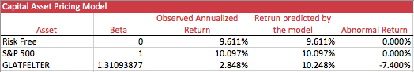Before building the Capital Asset Pricing Model (CAPM), my group members and I choose the 3-month U.S. Treasury Bills as our risk-free rate. As it represents the debt of the US Department of the Treasury, it has a close to zero default risk. We are able to calculate the expected return of Glatfelter using Security Market Line with given CAPM equation (E[R]=risk-free rate + beta*market risk premium).

The return of Glatfelter predicted by the model is 10.248%. By comparing with the observed annualized return, the abnormal return is -7.400%. The negative abnormal return indicates that Glatfelter underperformed relative to the market significantly. As only 17.795% of Glatfelter’s returns are the result of market movement, it is possible that there are other factors, such as decrease in forest area and environmental regulations mentioned earlier, impacting the returns of Glatfelter, accounting for 82.205% unsystematic risk. Since Glatfelter had an overall positive rate of return and relatively high beta value, it is a good choice of stock for risk loving investors.

**Diversification**

PH Glatfelter Company is in the Paper & Paper products industry of the consumer goods sector, which manufactures and sells specialty papers, such as receipts paper and envelopes, and fiber-based engineered materials worldwide. While our diversifier Electronic Arts Inc. operates in the Multimedia & Graphics software industry of the technology sector. Electronic Arts Inc. develops, and sells games, content and services for consoles, personal computers, mobile phones and tablets all over the world. [10] These two companies operate in very different, even competitive industries, which makes Electronic Arts Inc. a potential diversifying company for PH Glatfelter Co. Both companies have a worldwide business map. Since Electronic Arts has customers in all parts of the world, they would be less affected by economic fluctuations in any one country, so that the company is a less risky pitch. From the shareholder’s point of view, Electronic Arts has maintained a strong and stable performance over the years, which further proves the company’s stability.

The paper products industry is more of a traditional industry overall whereas Electronic Arts is a leader in the new technology industry. If the economy increases or a high-tech development occurs, more costumers would be attracted to the technology products and thus Electronic Arts would be likely to boost its performance. PH Glatfelter on the other hand might suffer since the traditional paper industry would be adversely impacted by tech booms and new medias, and people would need less cup ramen and other inferior products made with paper and fiber materials. Additionally, if the price of wood materials for paper and fiber increases, PH Glatfelter would drop while people tend to use more electronic services so Electronic Arts is likely to go up. Therefore, Electronic Arts mitigates the risk if wood material prices were to increase and people chose to use less paper. Because of its stability, wide geographic area covering and supplemental nature, Electronic Arts is a suitable diversifier of PH Glatfelter.

This claim can be supported by the data analysis of our two different companies. With a calculated correlation coefficient ρ of 0.1292, we can tell that the returns of PH Glatfelter and Electronic Arts from historical data are weak correlated. The diversification will lower the risk while maintain profitability.

|  |  |  |  |  |  |
| --- | --- | --- | --- | --- | --- |
| Table 1 | 100% GLT | 100% EA | S&P 500 | 50/50 | MVP |
| µ | 0.24% | 3.49% | 0.84% | 1.86% | 2.08% |
| σ | 9.73% | 8.63% | 3.13% | 6.91% | 6.86% |
| β | 1.3109 | 0.4832 | 1 | 0.8970 | 0.8408 |
| Coefficient of Variation | 40.98 | 2.47 | 3.72 | 3.71 | 3.33 |

As shown in the table above, expected returns (µ), standard deviations (σ) and coefficients of variation of the Minimum Variance Portfolio and the 50/50 Portfolio are different. The MVP portfolio consists of 44.06% GLT and 55.94% EA and has higher return than 100% GLT and 50/50 portfolio while minimizing the variation. What it means is that the MVP could generate the highest possible return while having the lowest possible risk. This comes from the optimal combination of GLT and EA stocks, so MVP is the ideal diversified portfolio.

**Conclusion**

Based on the Glatfelter’s business performance, stock prices and our research on the investment and diversification strategy, we would recommend the investors to buy the stock from Glatfelter if they are acceptable of the highly risky stock. The return of this stock is not fluctuating. Because the paper industry is a traditional industry and the market development remains stable right now. However, because of the arising of environmental issues, they lead to changes in industry and behavior at both business and personal levels. Under such circumstance, there’s increasing demand on the recycled paper and environmental friendly products. And Glatfelter is focusing on expanding the business on the relevant products.

With respect to diversification, we’d like to select the stock from Electronic Arts, because these two companies operate in very different, even competitive industries. According to the business performance of Electronic Arts, its stable market returns and good performances make it to be a convincing candidate for diversification. The weak correlation between two companies will significantly help lower the risk and maintain the profitability.

MVP accounts for the optimal amount of risk and return of two stocks. Investing in the MVP will provide adequate returns for the minimal risk, and therefore it provides fairly safe and also beneficial investment. We recommend the investors to invest in 44.06% GLT and 55.94% EA.

All the data are derived from the historical data from the past three years. In real world, the returns would change significantly in accordance with different situations. The market is unpredictable and our calculation and approximation is only based on current market trends and market conditions. We cannot guarantee the expected returns and potential benefits when investing in the Glatfelter Company.

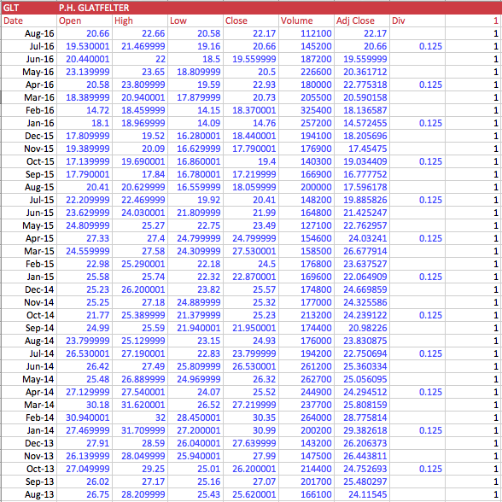

Appendix A

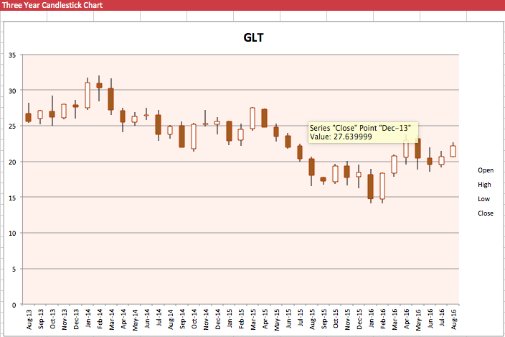



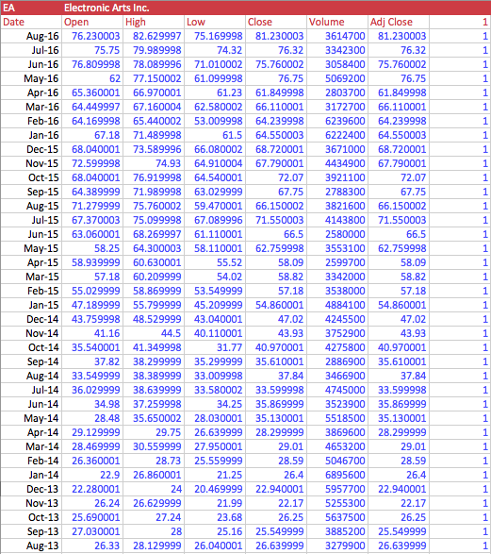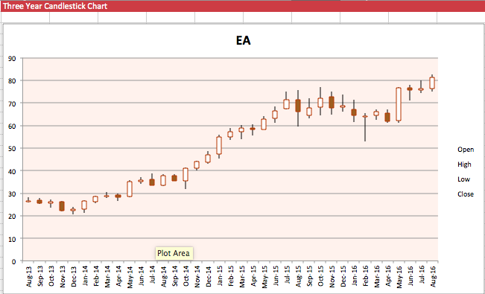

Appendix B



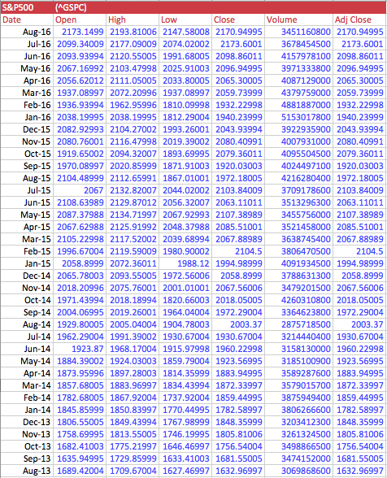

Appendix C

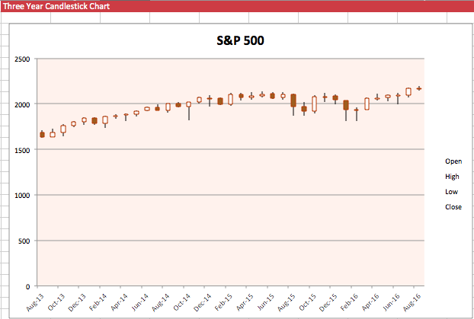

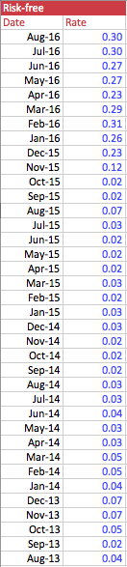

Appendix D



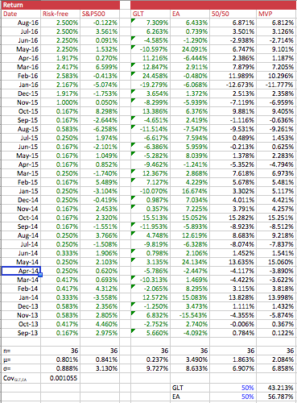

Appendix E

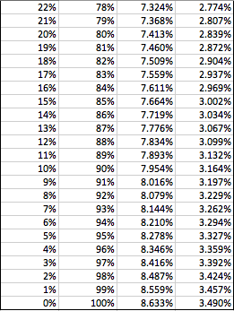

Appendix F

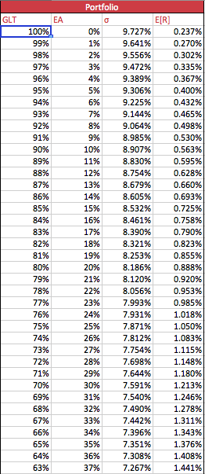

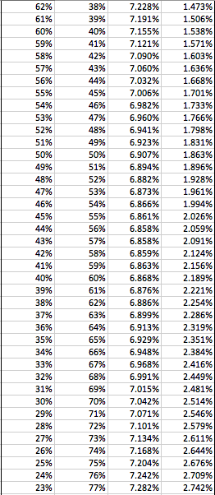

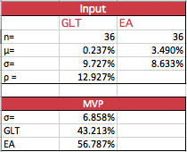

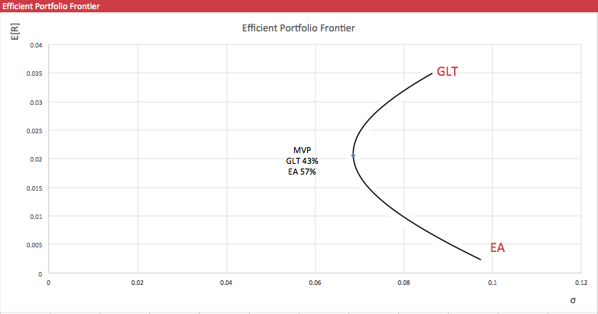

Appendix G

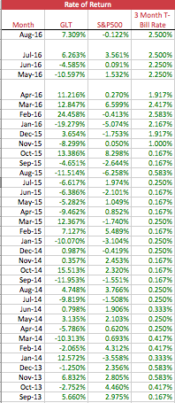

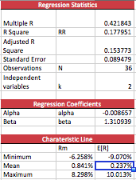

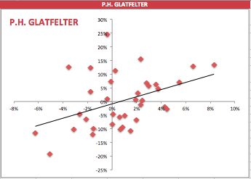

Appendix H

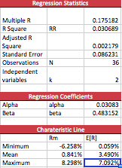

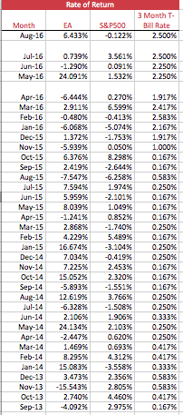

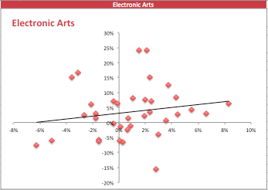

Appendix I

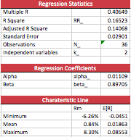

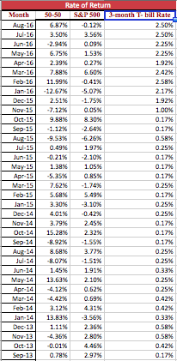

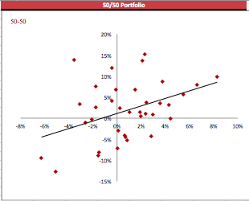

Appendix J

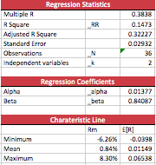

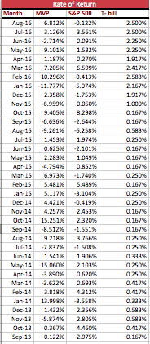

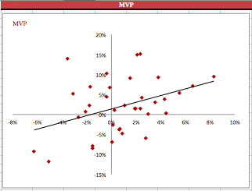

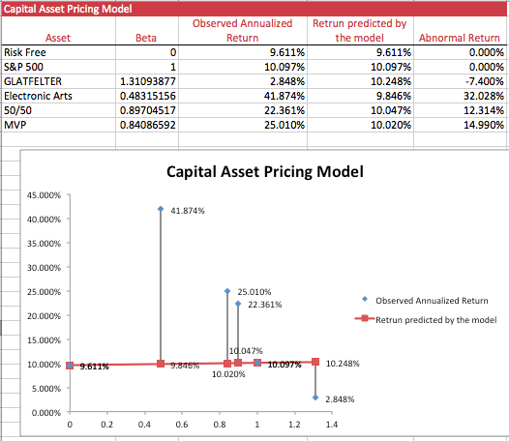

Appendix K

1. "P.H. Glatfelter Company." The Business Journals. Accessed September 28, 2016. http://www.bizjournals.com/company/p-h-glatfelter-company/197755.
2. Glatfelter Company. “Celebrating Over 150 Years of Sustainability.” Accessed Sept 25, 2016.

   <http://www.glatfelter.com/about_us/history.aspx>
3. Yahoo Finance. “GLT.” Accessed Sept 25, 2016.

   <https://finance.yahoo.com/quote/GLT/financials?ltr=1>
4. Yahoo Finance. “Industry Center - Paper & Paper Products.” Accessed Sept 25, 2016.

   <https://biz.yahoo.com/ic/324.html>
5. Yahoo Finance. “Leaders & Laggards in Paper & Paper Products.” Accessed Sept 25, 2016.

   <https://biz.yahoo.com/ic/ll/324g5r.html>
6. Glatfelter Company. “A Diverse Line of Nonwovens and Long Fiber Paper.” Accessed Sept 25, 2016.

   <http://www.glatfelter.com/Files/products/technical/default.aspx>
7. Brigham, Eugene F., and Joel F. Houston. Fundamentals of Financial Management. Mason, OH: Thomson/South-Western, 2004.
8. "SPX Quote." Bloomberg.com. Accessed September 27, 2016. http://www.bloomberg.com/quote/SPX:IND.
9. "GLT : Summary for Glatfelter Common Stock - Yahoo Finance." GLT : Summary for Glatfelter Common Stock - Yahoo Finance. Accessed September 27, 2016. https://finance.yahoo.com/quote/GLT?p=GLT.
10. Yahoo Finance. “EA”

    <https://finance.yahoo.com/quote/EA/profile?p=EA> (accessed Sept36, 2015)